1. 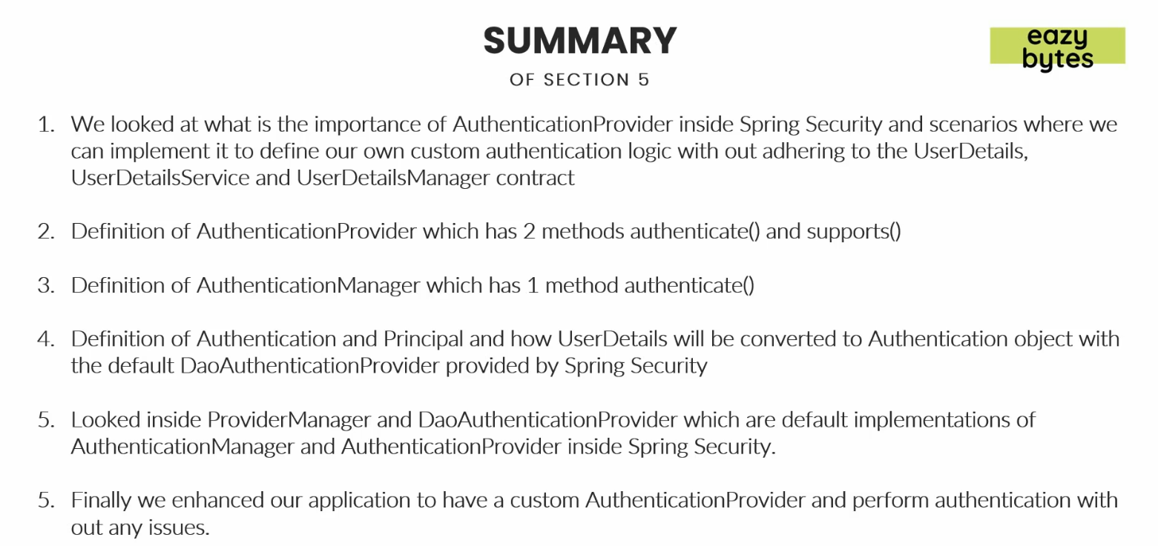
2. There a zip file containing resource.